**Control Structures**

if...then

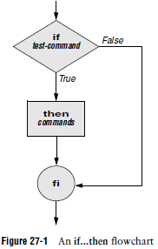

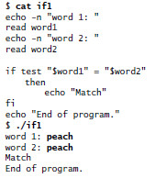

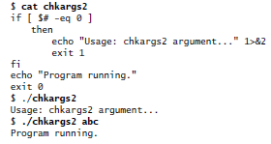

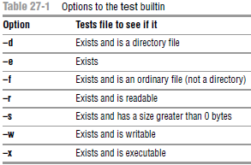

if...then...else

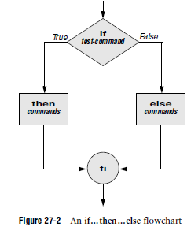

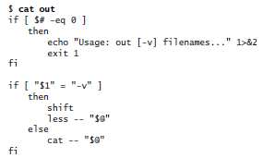

if...then...elif

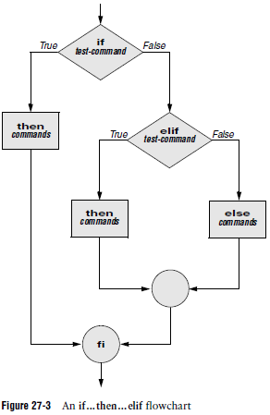

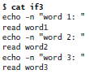

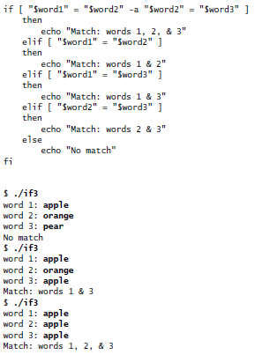

for...in

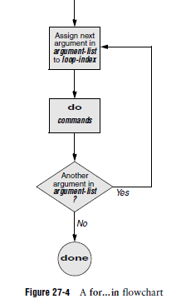

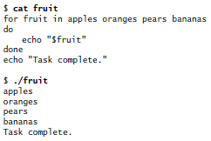

for

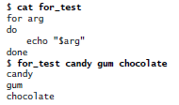

while

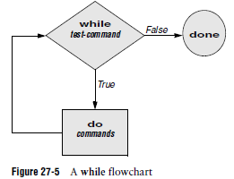

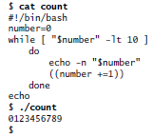

until

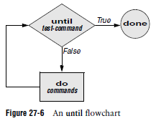

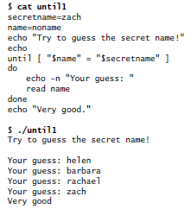

break and continue

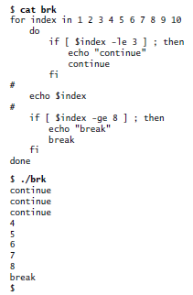

Case

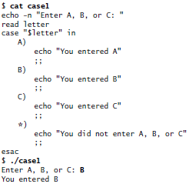

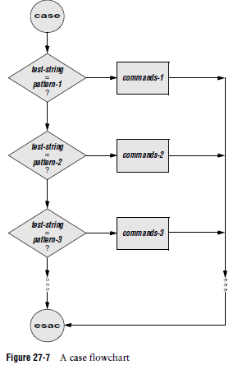

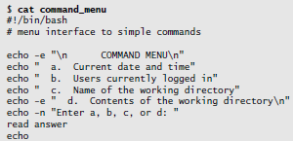

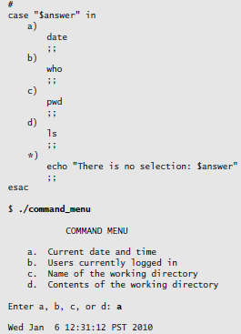

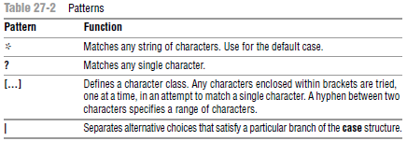

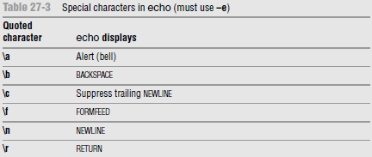

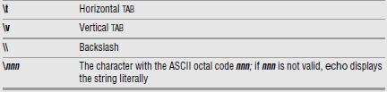

Select

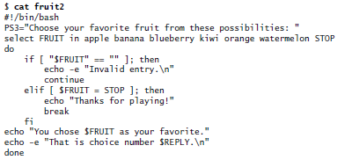

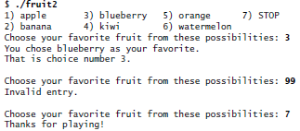

Here Document

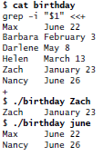

The two less than symbols (**<<**) in the first line indicate a Here document follows.

**File Descriptors**

Typical Linux process starts with three open files: standard input (file descriptor 0), standard output (file descriptor 1), and standard error (file descriptor 2).

The Bourne Again Shell opens files using the exec builtin as follows:

*exec* ***n****>* ***outfile***

*exec* ***m****<* ***infile***

Duplicating a file descriptor:

*exec* ***n****<&****m***

*exec* ***n****<&–*

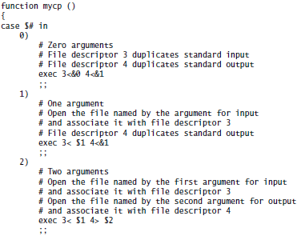

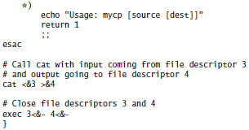

**Parameters and Variables**

Array Variables

$ **NAMES=(max helen sam zach)**

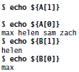

Locality of Variables

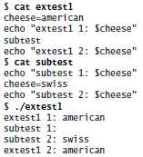

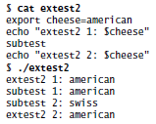

Functions

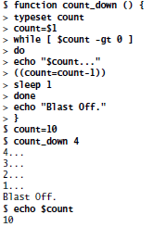

**Special Parameters**

$$: PID Number

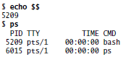

$?: Exit Status

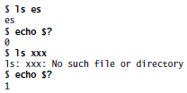

**Positional Parameters**

$#: Number of Command-Line Arguments

C:\Users\JJ\Desktop\Capture.PNG

$0: Name of the Calling Program

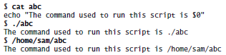

$1–$n: Command-Line Arguments

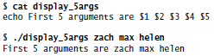

shift: Promotes Command-Line Arguments

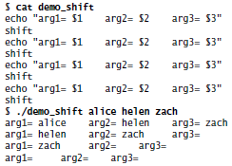

set: Initializes Command-Line Arguments

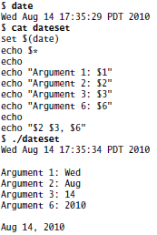

$**\*** and $@: Represent All Command-Line Arguments

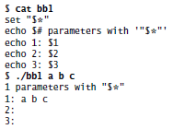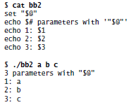

Expanding Null and Unset Variables

:– Uses a Default Value

*${****name****:–****default****}*

:= Assigns a Default Value

*${****name****:=****default****}*

:? Displays an Error Message

*${****name****:?****message****}*

**Builtin Commands**

type: Displays Information About a Command

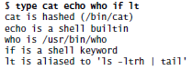

read: Accepts User Input

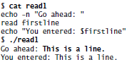

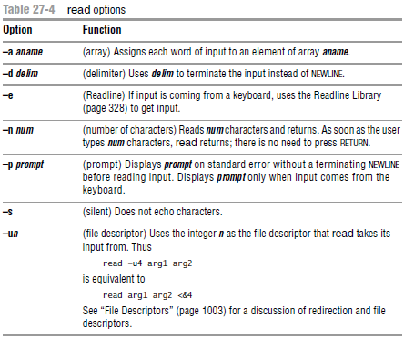

**exec: Executes a Command or Redirects File Descriptors**

exec: Executes a Command

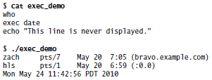

exec: Redirects Input and Output

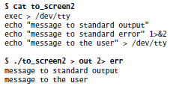

trap: Catches a Signal

*trap [****'commands'****] [****signal****]*

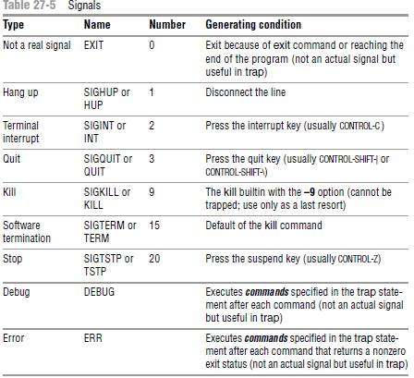

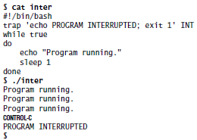

kill: Aborts a Process

*kill [–****signal****]* ***PID***

getopts: Parses Options

*getopts* ***optstring varname*** *[****arg ...****]*

1. A **–b** option indicates that the program should ignore whitespace at the start of input lines.

2. A **–t** option followed by the name of a directory indicates that the program should store temporary files in that directory. Otherwise, it should use **/tmp**.

3. A **–u** option indicates that the program should translate all output to uppercase.

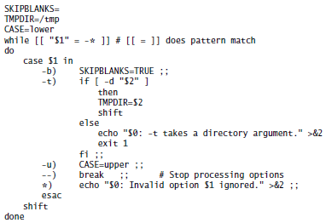

**Expressions**

Arithmetic Evaluation

$ let "VALUE=VALUE * 10 + NEW"

$ let "COUNT = COUNT + 1" VALUE=VALUE*10+NEW

Logical expressions

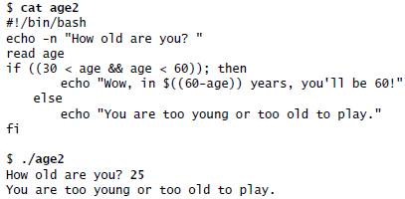

Logical Evaluation (Conditional Expressions)

if [[ 30 < $age && $age < 60 ]]; then

String comparisons

$ **[[ artist = a* ]]**

$ **echo $?**

0

$ **[[ a* = artist ]]**

$ **echo $?**

1

A Partial List of Builtins

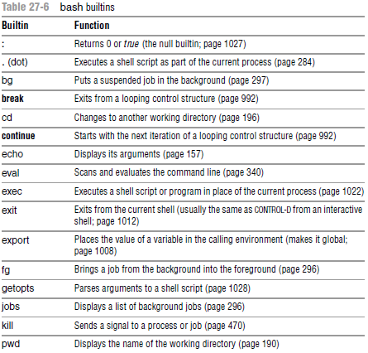

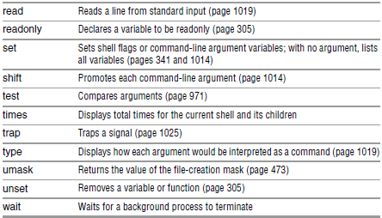

String Pattern Matching

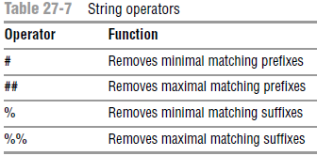

*${****varname op pattern****}*

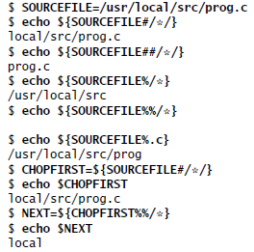

Here the string-length operator, **${#*name*}**, is replaced by the number of characters in the value of **name**:

$ **echo $SOURCEFILE**

/usr/local/src/prog.c

$ **echo ${#SOURCEFILE}**

21

Operators

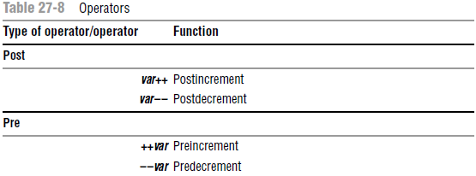

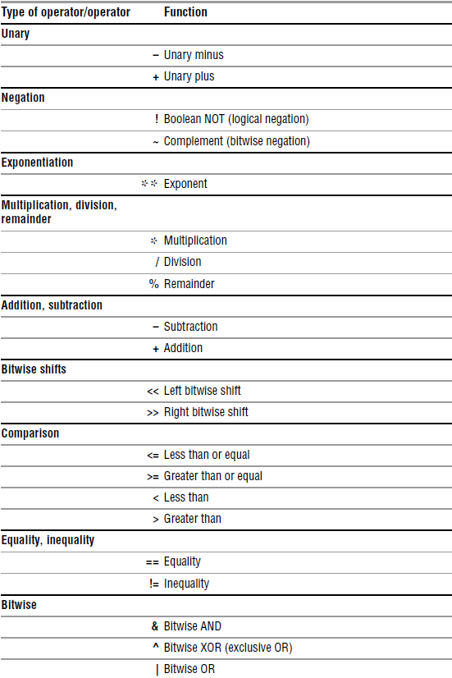

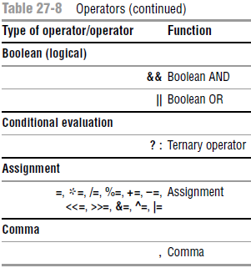

Pipe

$ **cmd1 | cmd2 || cmd3 | cmd4 && cmd5 | cmd6**

is interpreted as if you had typed

$ **((cmd1 | cmd2) || (cmd3 | cmd4)) && (cmd5 | cmd6)**

Increment and decrement

$ **N=10**

$ **echo $N**

10

$ **echo $((--N+3))**

12

$ **echo $N**

9

$ **echo $((N++ - 3))**

6

$ **echo $N**

10

Remainder: **%**

Boolean: **&&** (AND) and **||** (OR)

Ternary

The ternary operator, **? :**, decides which of two expressions should be evaluated,

based on the value returned by a third expression:

***expression1*** *?* ***expression2*** *:* ***expression3***

Assignment: The assignment operators, such as **+=**, are shorthand notations.